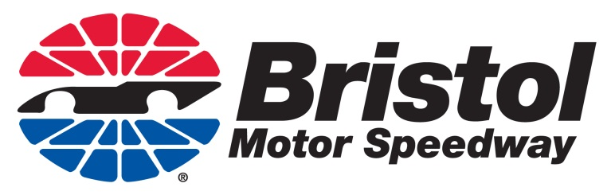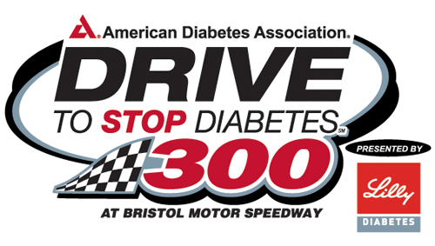

Identification of Event Speakers in Order of Presentation

VIDEO
Welcome – Lynsey Wilson, Communications Manager, Bristol Motor Speedway
Jerry Caldwell, General Manager, Bristol Motor Speedway
Mike Mason, Vice President, U.S., Lilly Diabetes
Steve Wosahla, American Diabetes Association
Ryan Reed, NASCAR Nationwide Series (NNS) driver

AUDIO
Soundbite 1: Mike Mason, Vice President, U.S., Lilly Diabetes
Soundbite 2: Steve Wosahla, American Diabetes Association
Soundbite 3: Ryan Reed, NASCAR Nationwide Series (NNS) driver

